Q1.

a.

.

=

=

At x=9,= = 2.(3)3 = 54

At x=4,= = 2.(2)3 = 16

. = 54-16= 38

b.

. $\int_{1}^{e}{ln xdx}$

Using integration by parts,

. $\int{ln⁡(x) dx}$ = xln(x)-x+C

. $\int_{1}^{e}{ln⁡(x)dx}$ = [ xln(x)-x]e1

At x=e,

e ln(e)-e=e(1)-e=0

At x=1,

1ln(1)-1=0-1=-1

. $\int_{1}^{e}{ln⁡(x)dx}$ = 0-(-1)=1

c.

. $\int_{0}^{1}{\cos^{-1}⁡(x)dx}$

The integral of cos-1 is

= x cos-1(x)- +C

. = [xcos−1(x)−]10

At x=1,

1⋅cos−1(1)− = 1⋅0−0=0

At x=0,

0⋅cos−1(0)− = 0−1= -1

= 0-(-1) = 1

d.

. $\int_{-1}^{1}{cos⁡(\frac{πx}{2})dx}$

The function cos($\frac{πx}{2}$) is even, because cos is an even function. For even functions, the integral over symmetric limits simplifies as,

. $\int_{-1}^{1}{cos⁡(\frac{πx}{2})dx}$ = 2 $\int_{0}^{1}{π cos⁡(\frac{πx}{2})dx}$

. $2π\int_{0}^{1}{ cos⁡(\frac{πx}{2})dx}$

*. $\int{\cos\left(\frac{πx}{2}\right)dx}$* = $\frac{sin\frac{πx}{2}}{\frac{π}{2}}$ = $\frac{π}{2}$ sin(

. = [sin ( ]10

At x=1,

sin ( $\frac{π.1}{2})$ = $\frac{2}{π}$ sin ( $\frac{π}{2})$ = $\frac{2}{π}$.1 = $\frac{2}{π}$

At x=0,

$\frac{2}{π}$ sin ( $\frac{π.0}{2})$ = $\frac{2}{π}$.0 = 0

.2 $π($ $\frac{2}{π}$– 0) = 2 $π.$ $\frac{2}{π}$ = 4

Q2.

a.

. $\int{x^{2}{cos⁡(x}^{3}) dx}$

Let u= $x^{3}$,

du= $3x^{2}$ dx

$x^{2}$ dx = $\frac{du}{3}$

. $\int{x^{2}{cos⁡(x}^{3}) dx}$ = $\int{\cos\left(u\right)}\frac{du}{3}$

Simplifies,

. $\frac{1}{3}\int{\cos\left(u\right)du}$

. $\frac{1}{3}$ sin(u)+C

So, sin (x3)+C

b.

.

Let u=1+sin(3t),

du= 3cos(3t)dt

cos (3t)dt = $\frac{du}{3}$

. $\int{\frac{\cos\left(3t\right)}{1+\sin\left(3t\right)} dx}$ = $\int{\frac{1}{u}}$. $\frac{du}{3}$

. $\frac{1}{3}$ $\int{\frac{1}{u}}$ du

The integral of $\frac{1}{u}$ is,

ln $\left|u\right|$ +C

So, $\frac{1}{3}$ ln $\left|u\right|$ +C

Substitution,

. $\frac{1}{3}$ ln $\left|1+sin⁡(3t)\right|$ +C

Q3.

f(x)=x3-5x2+30

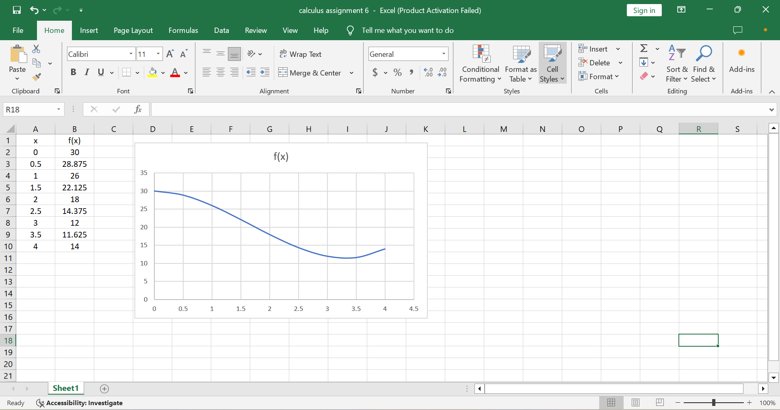

**.** = - +30x

At x=0: 0

At x=4: 64- $\frac{320}{3}$ +120 = $\frac{232}{3} ≈$ 77.33

Average value: $\frac{77.33}{4}$ $≈$ 19.33